INTRA-DISCIPLINARY PROJECT-II REPORT

**“LIBRARY MANAGEMENT SYSTEM”**

**Submitted**

by

|  |  |
| --- | --- |
| Ms. J Hamsini  201FA04443 | Ms. D Akhila  201FA04448 |
| Ms.CH Naga Alekhya  201FA04457 | |

Under the guidance of

***Dr.B.Samatha***

***Assistant professor,CSE***

***Mrs.G.Keerthi***

***Assistant professor,CSE***



**DEPARTMENT OF COMPUTER SCIENCE & ENGINEERING**

**VIGNAN’S FOUNDATION FOR SCIENCE, TECHNOLOGY AND RESEARCH**

**DEEMED TO BE UNIVERSITY**

VADLAMUDI, GUNTUR DIST, ANDHRA PRADESH, INDIA, PIN-522 213



**DEPARTMENT OF COMPUTER SCIENCE & ENGINEERING**

**VIGNAN’S FOUNDATION FOR SCIENCE, TECHNOLOGY AND RESEARCH**

**DEEMED TO BE UNIVERSITY**

**CERTIFICATE**

This is to certify that the Intra-Disciplinary Project-II entitled **“LIBRARY MANAGEMENT SYSTEM”** that is being submitted by **J.Hamsini(201FA04443),**

**D.Akhila(201FA04448),CH.Naga Alekhya(201FA04457)** for partial fulfillment of Intra-Disciplinary Project-II is a bonafide work carried out under the supervision of ***Dr.B.Samatha, Assistant professor, Mrs.G.Keerthi, Assistant professor*** from Department of Computer Science & Engineering.

*Name of the Guide* HEAD OF THE DEPARTMENT

***Dr.B.Samatha* Dr.Venkatesulu Dondeti** ***Assistant professor,CSE***

***Mrs.G.Keerthi***

***Assistant professor,CSE***

Internal Examiner External Examiner



**DEPARTMENT OF COMPUTER SCIENCE & ENGINEERING**

**VIGNAN’S FOUNDATION FOR SCIENCE, TECHNOLOGY AND RESEARCH**

**Deemed to be UNIVERSITY**

VADLAMUDI, GUNTUR DIST, ANDHRA PRADESH, INDIA, PIN-522 213

**DECLARATION**

We hereby declare that the Intra-Disciplinary Project-II entitled **“LIBRARY MANAGEMENT SYSTEM”** is being submitted by **J.Hamsini(201FA04443), D.Akhila(201FA04448),CH Naga Alekhya(201FA04457)** in partial fulfillment of Intra-Disciplinary Projects-II course work. This is our original work, and this project has not formed the basis for the award of any degree. We have worked under the supervision of **Dr.B.Samatha**,***,Assistant professor, Mrs.G.Keerthi, Assistant professor*** from the Department of Computer Science & Engineering.

By

J.Hamsini(201FA04443)

D.Akhila(201FA04448)

CH NagaAlekhya(201FA04457)

Date:

**CONTENTS**

1. **Introduction ……………………………………………………05**
   1. Introduction
   2. Objective
   3. Project Description
2. **Requirements & specifications………………………………...06**
   1. Software Requirements
   2. Hardware Requirements
3. **Design……………………………………………………………06**
   1. ER Diagram
   2. Database Schema
4. **Implementation…………………………………………………08**
   1. Database
   2. Sample Source Code
5. **Results……………………………………………………………11**

**6. References………………………………………………………..18**

**7. Conclusion……………………………………………………….18**

**1.INTRODUCTION**

**1.1 Introduction**

* Library is a place where all kinds of books are available. The Library Management System is an application for assisting a librarian in managing a book library in university.
* The system would provide a basic set of features to add/update members, add/update books, and manage check-in specifications for the systems based on the reader's statement of need.

**1.2 Objective**

* The development of this new library management system contains the following activities, which try to automate the entire process.
* Automates information related to all book.
* Providing security.
* Maintaining database for all above include reservations of books.
* Time saving.

**1.3 Project description**

* Library Management System maintains the information about the books present in the library, their authors, the members of library to whom books are issued, library staff and all.
* This is very difficult to organize manually &maintenance of all this information is also a very complex task.
* So, our project would provide basic set of features to add/update members, add/update books, and manage check in specifications for the systems based on the client’s statement of need.
* Student’s can search books based on the subject name.
* They can send Remarks.
* They can check the availability of books.
* Admin can manage records very easily using this software.
* This software reduces time consumption ,space consumption and increases efficiency.

**2.REQUIREMENTS AND SPECIFICATIONS**

**2.1Software Requirements**

* MY SQL Workbench 8.0 CE
* MY SQL connector
* NetBeans IDE 8.2
* Front-End: JSP, Html, CSS, JS.  
  Server-side: Servlet.  
  Back-end: MYSQL.  
  Server: Tomcat 10.0.21.

**2.2Hardware Requirements**

* Basic requirements of computer(No specific requirements are required to run this library management system.

**3.DESIGN**

**3.1 ER diagram**

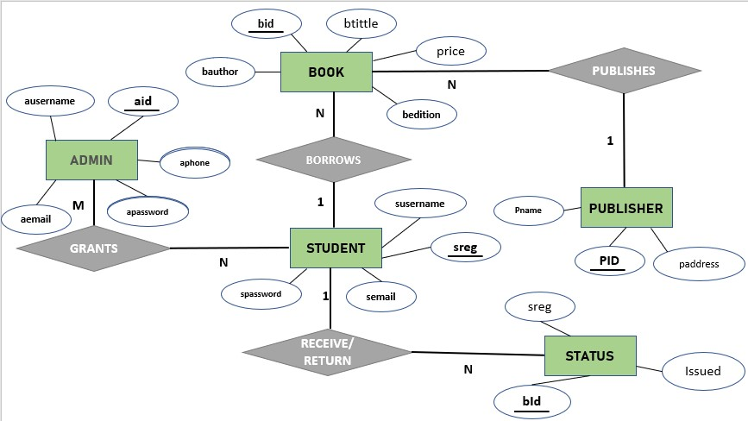

**3.2Database schema**

**studentregistration**

|  |  |  |  |
| --- | --- | --- | --- |
| Susername | spassword | sreg | semail |

**adminregistration**

|  |  |  |  |  |
| --- | --- | --- | --- | --- |
| ausername | apassword | aphone | aid | aemail |

**publisher**

|  |  |  |
| --- | --- | --- |
| pid | paddress | pname |

**book**

|  |  |  |  |  |  |  |
| --- | --- | --- | --- | --- | --- | --- |
| Btittle | bid | bcategory | bprice | bauthor | bedition | pid |

**status**

|  |  |  |
| --- | --- | --- |
| bid | sreg | issued |

**remarks**

|  |  |
| --- | --- |
| sreg | remark |

**4.IMPLEMENTATION**

**4.1Database**

* create database lms;
* use lms;
* create table studentregistration(susername varchar(40),spassword varchar(40),sreg varchar(40) primary key,semail varchar(40));
* create table adminregistration(ausername varchar(40),apassword varchar(40),aphone varchar(40) ,aid varchar(40) primary key,aemail varchar(40));
* create table publisher(pid varchar(40)primary key,paddress varchar(40),pname varchar(40));
* create table book(btittle varchar(40),bid varchar(40) primary key,bcategory varchar(40) ,bprice varchar(40),bauthor varchar(40),bedition varchar(40),pid varchar(40),foreign key(pid) references publisher(pid));
* create table status(bid varchar(40),sreg varchar(40),issued varchar(40),dued varchar(40),foreign key (bid) references book(bid),foreign key (sreg) references studentregistration(sreg),primary key(bid,sreg));
* create table remarks(sreg varchar(40),remarks varchar(500),foreign key (sreg) references studentregistration(sreg));

**4.2 Sample source code**

HTML Code:

<!DOCTYPE html>

<html>

head>

<title>adminlogin</title>

<style>

body

{

background-image:url('adminregistration.jpg');

background-repeat:no-repeat;

background-attachment:fixed;

background-size:100% 100%;

}

table

{

border:solid 5px;

border-color:black;

}

</style>

</head>

<body>

<form name="adminlogin" action="adminlogin" method="">

<table cellpadding="10" style="position:relative;left:750px;top:50px;">

<tr>

<td>

a_id :<input type="text" name="aid" placeholder="ex:20A010" required> <br><br>

Password:<input type="password" name="apassword" placeholder="Password" required>

<br>

<input type="reset"value="Reset">

<buttonon click=validate(); >Login </button>

</td>

</tr>

</pre>

</table>

</form>

</body>

</html>

Servlet Code:

import java.io.IOException;

import java.io.PrintWriter;

import java.sql.Connection;

import java.sql.DriverManager;

import java.sql.PreparedStatement;

import java.sql.ResultSet;

import java.sql.SQLException;

import javax.servlet.RequestDispatcher;

import javax.servlet.ServletException;

import javax.servlet.http.HttpServlet;

import javax.servlet.http.HttpServletRequest;

import javax.servlet.http.HttpServletResponse;

public class Adminlogin extends HttpServlet {

public void doGet(HttpServletRequest req, HttpServletResponse res)

throws ServletException, IOException {

res.setContentType("text/html;charset=UTF-8");

PrintWriter out = res.getWriter();

String admin=req.getParameter("aid");

String pass=req.getParameter("apassword");

try{

Class.forName("com.mysql.cj.jdbc.Driver");

Connection con = DriverManager.getConnection("jdbc:mysql://localhost/lms","root","29H072003*");

PreparedStatement stmt=con.prepareStatement("select apassword from adminregistration where aid='"+admin+"';");

ResultSet rs=stmt.executeQuery();

String dbpass=null;

if( rs.next()){

dbpass = rs.getString(1);

}

int l=1;

if(pass.equals(dbpass))

{

l=0;

}

if(l==0)

{

RequestDispatcher rd=req.getRequestDispatcher("Adminnav.html");

rd.forward(req, res);

}

else

{

out.println("<h1>"+"sorry.... invalid username or password"+"</h1>");

import java.io.IOException;

import java.io.PrintWriter;

}

}

catch(ClassNotFoundException | SQLException e)

{

out.println(e);

}

}

}

}

catch(ClassNotFoundException | SQLException e)

{

out.println(e);

}

}

}

**output:**

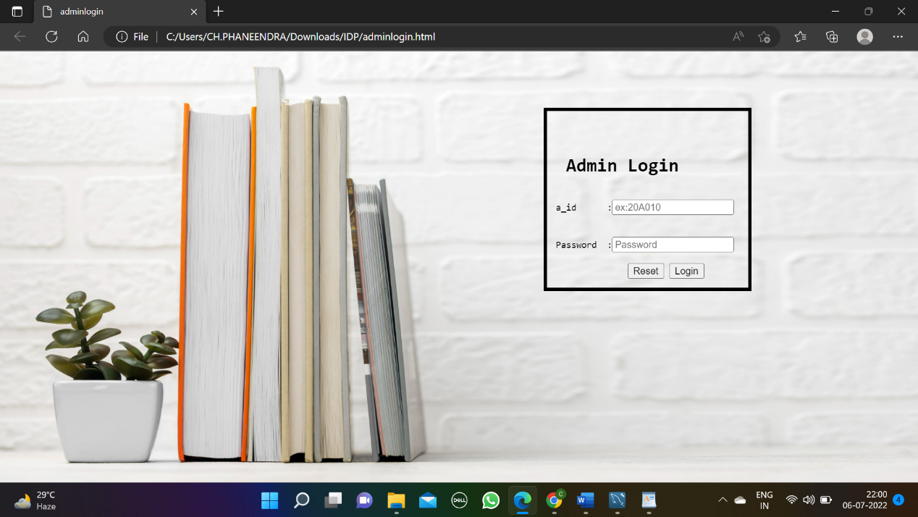

**If valid credentials are entered it will redirect to admin page**

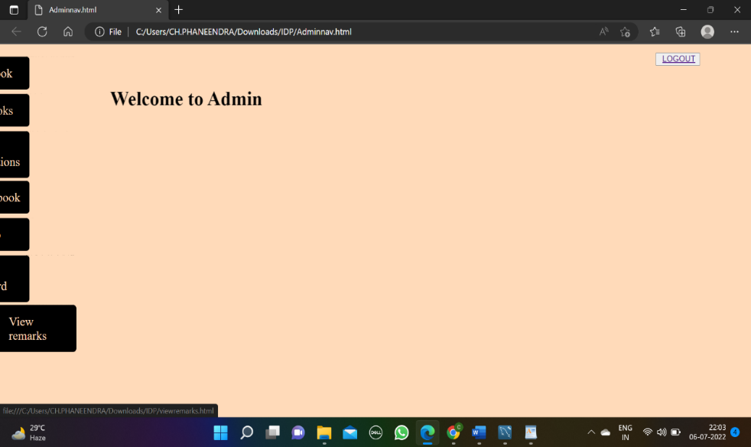

**Otherwise ,it will display ”Not Valid”**

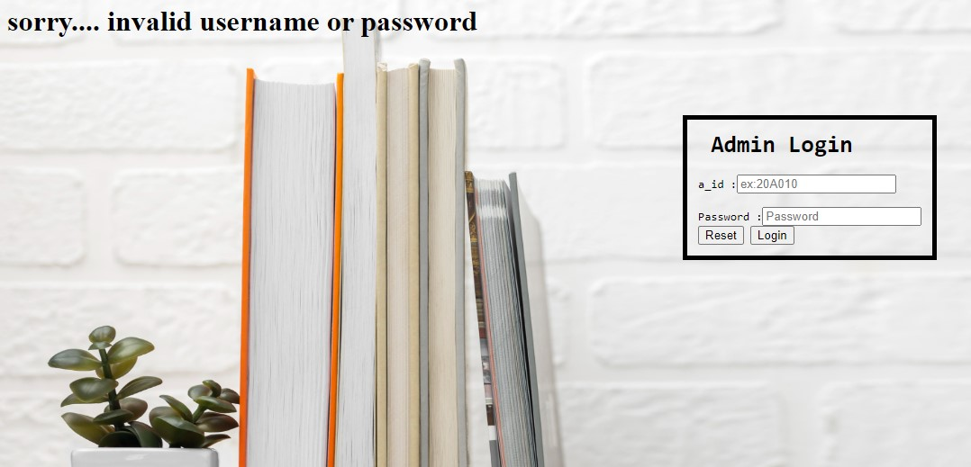

**5.RESULTS**

HOME PAGE

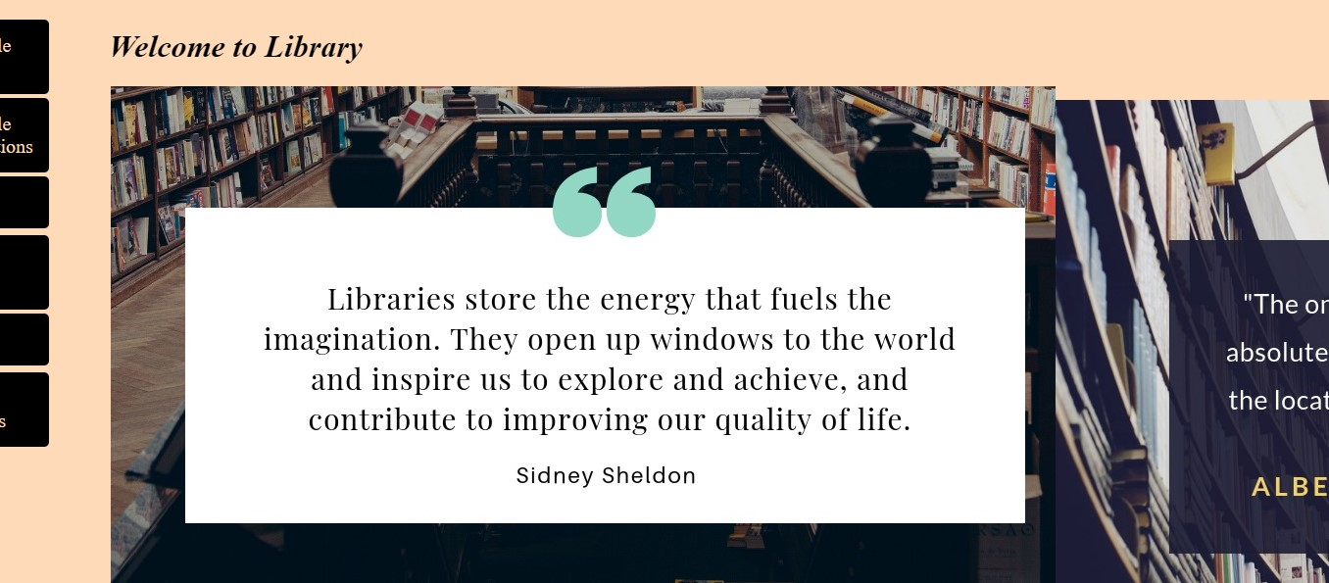

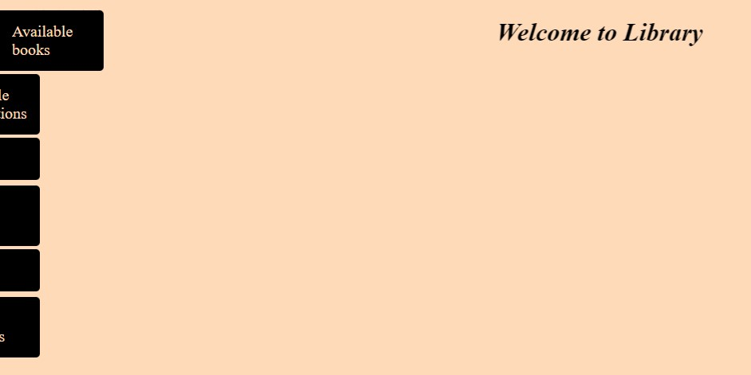AVAILABLE BOOKS



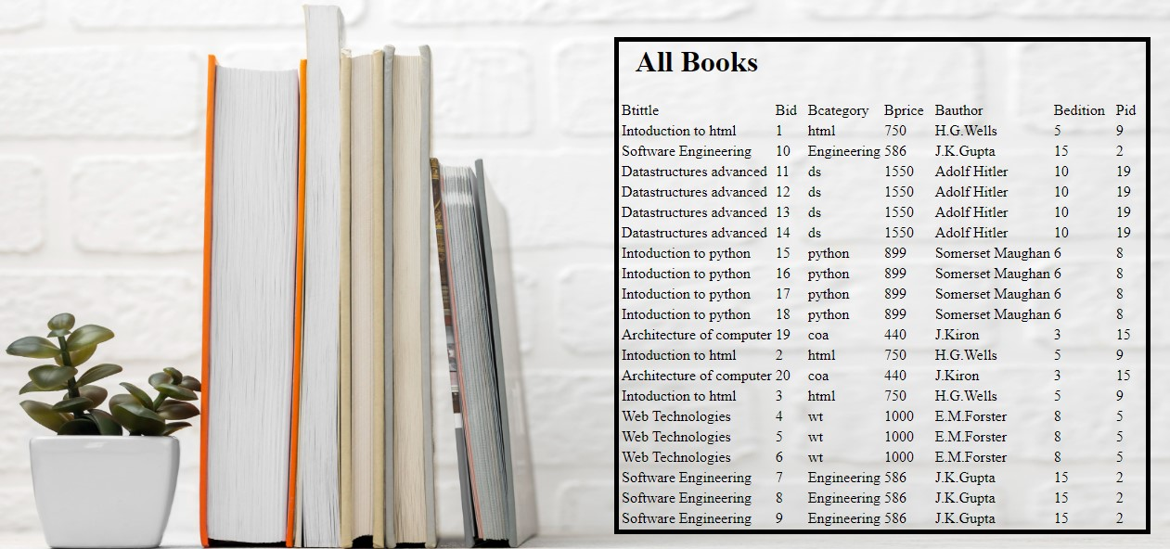

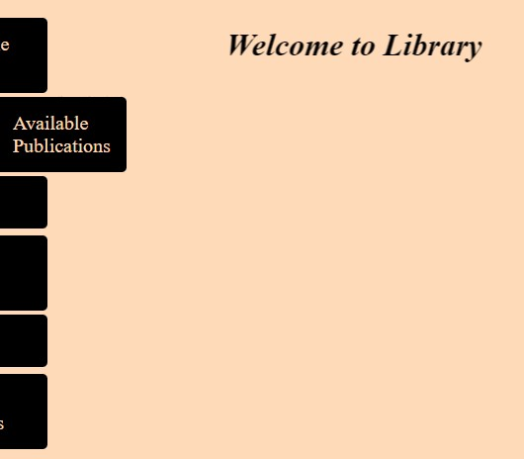AVAILABLE PUBLISHERS



**PUBLISHERS**

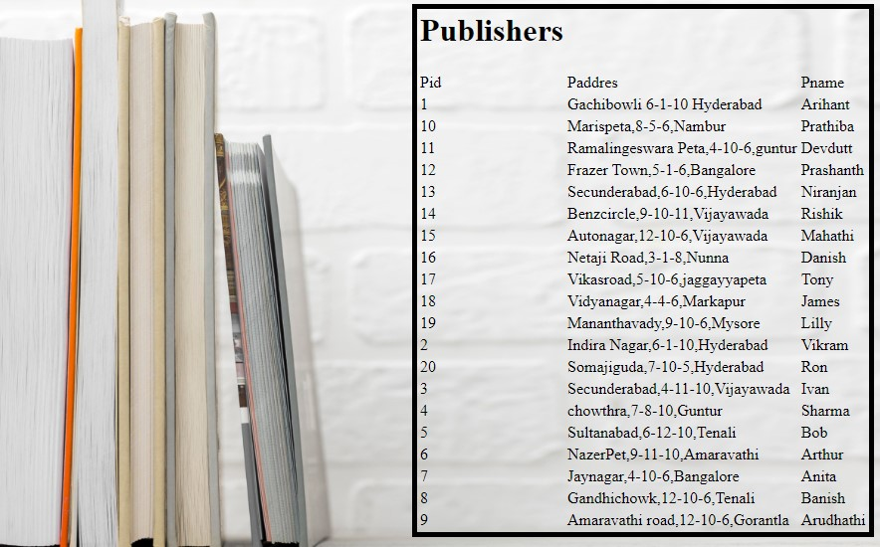

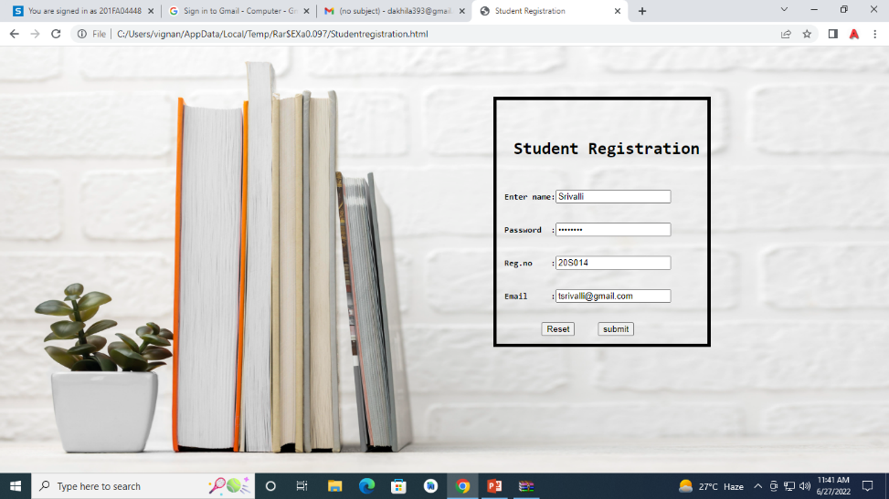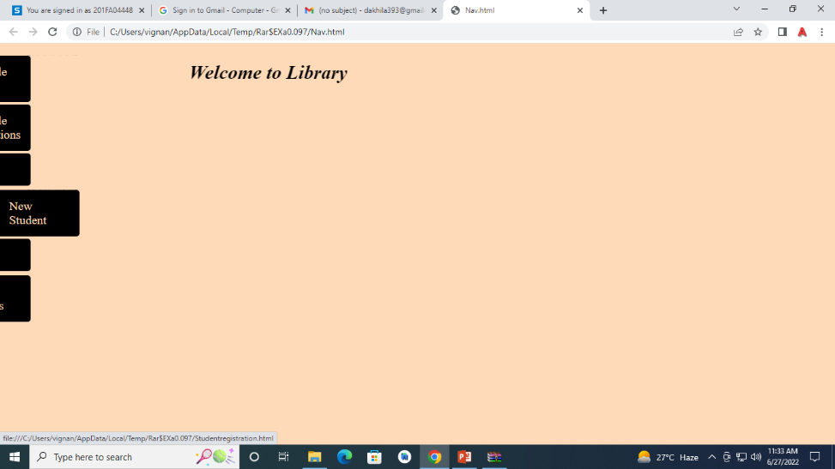NEW STUDENT

**DATABASE**

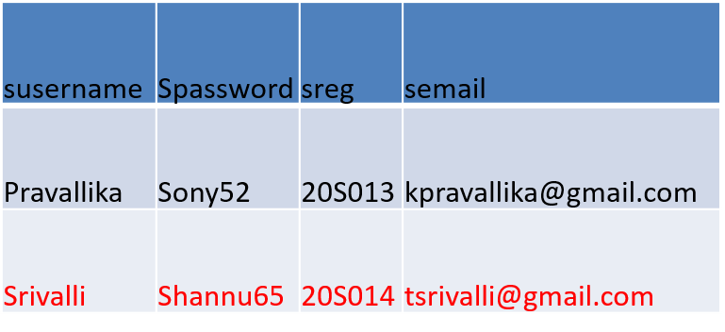

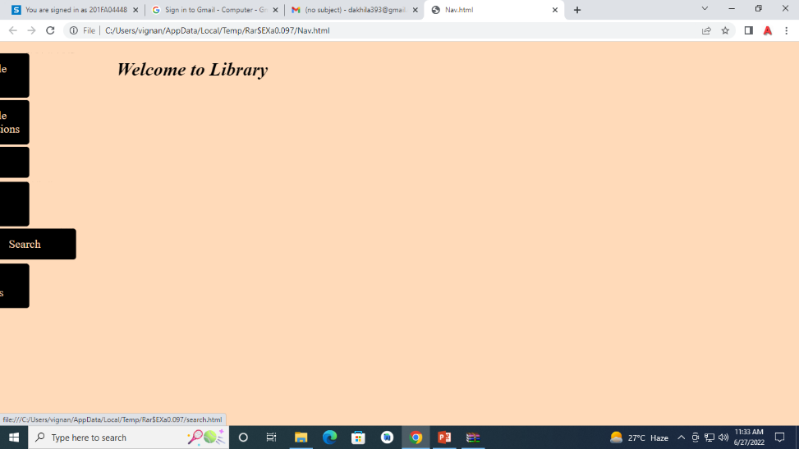SEARCH

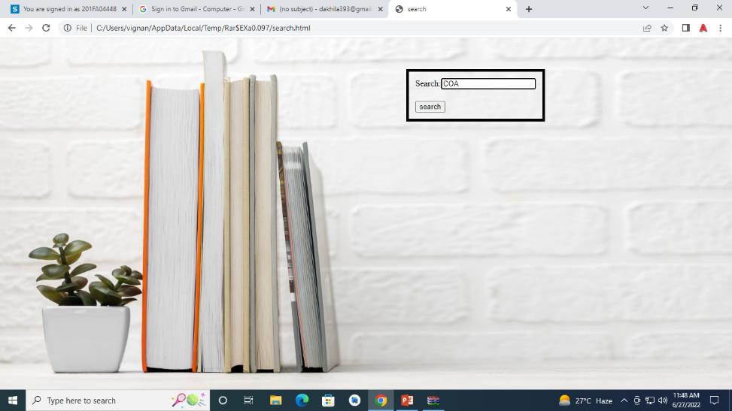

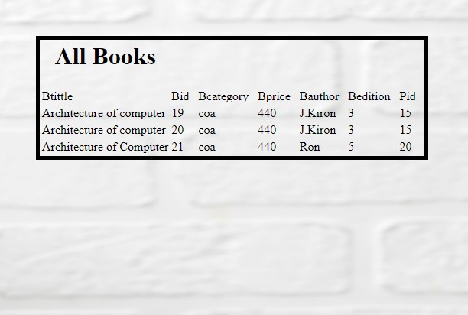

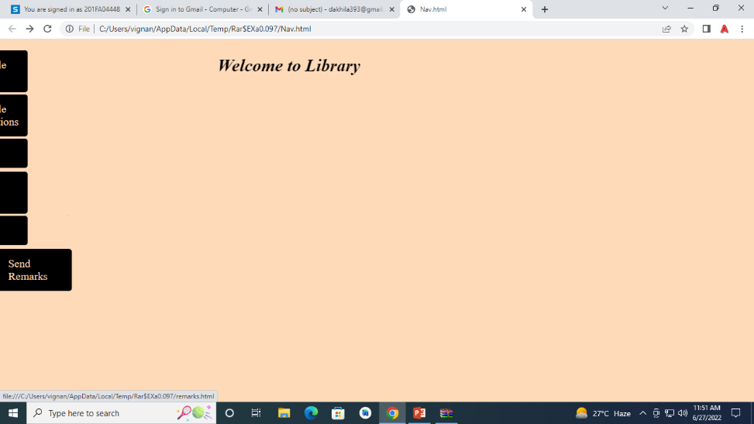SEND REMARKS

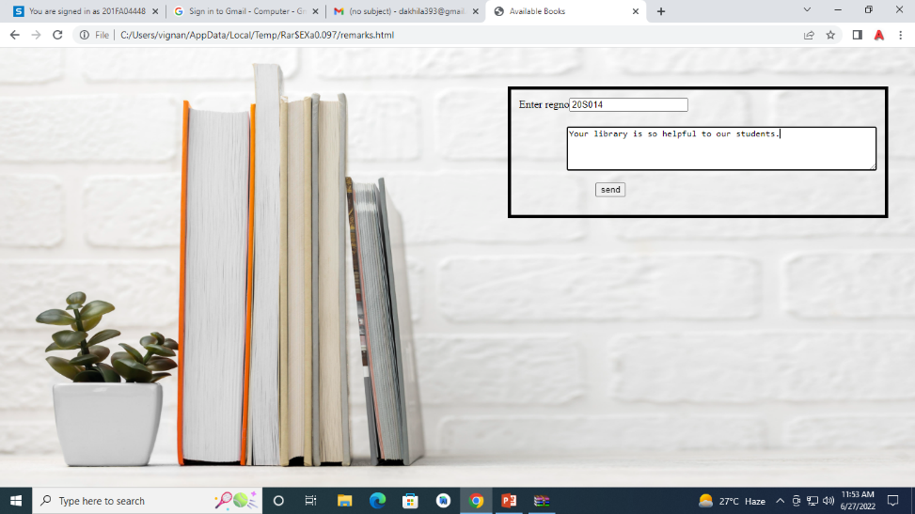

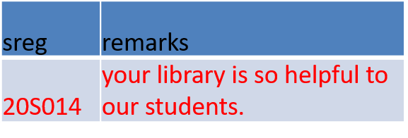

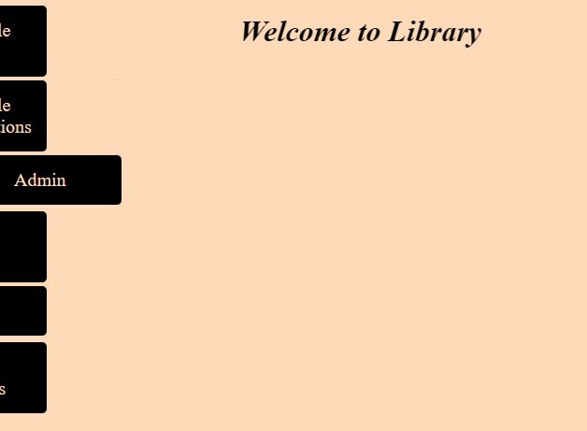ADMIN LOGIN



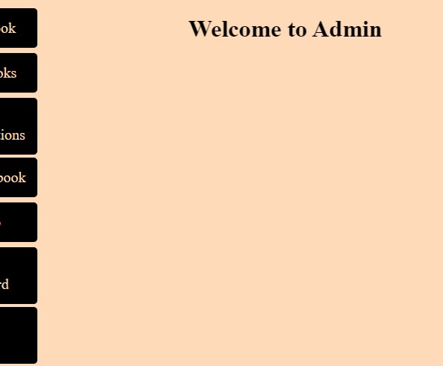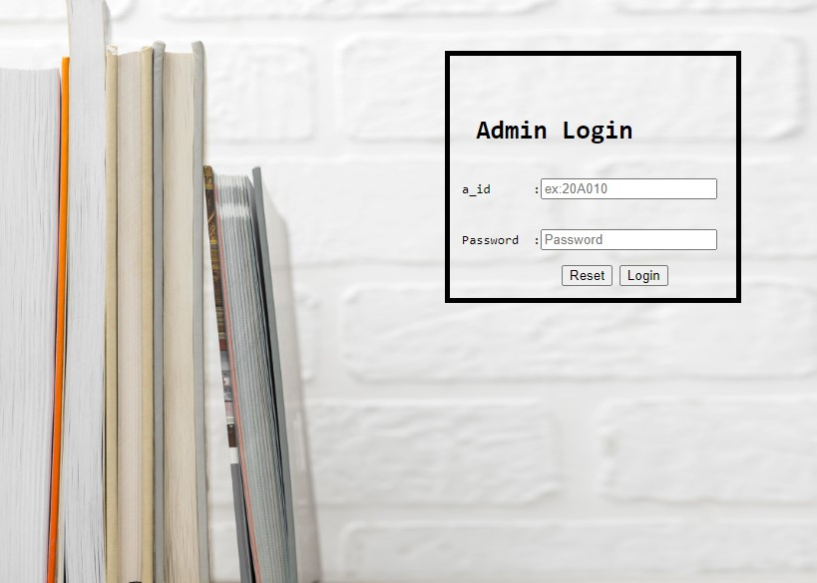

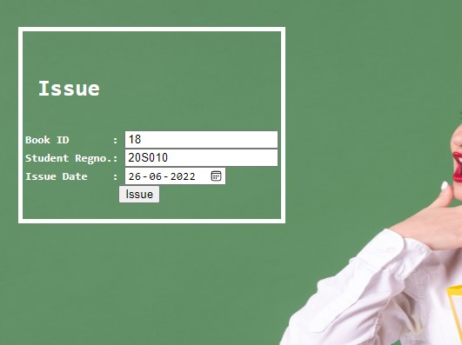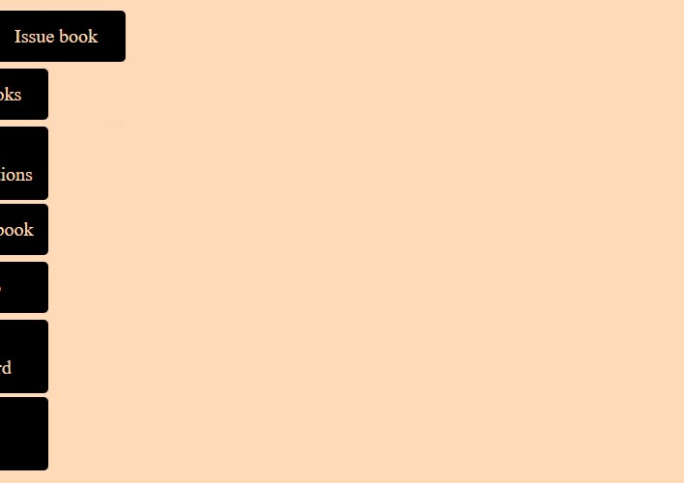ISSUE BOOK

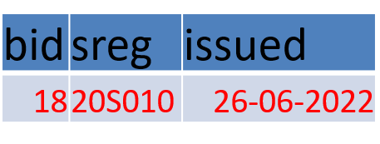

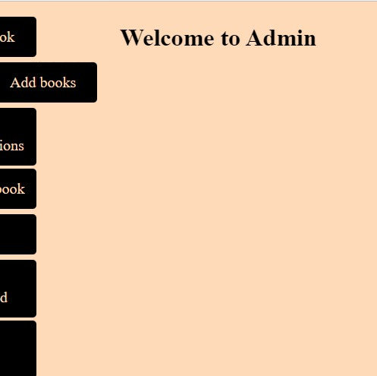ADD BOOK

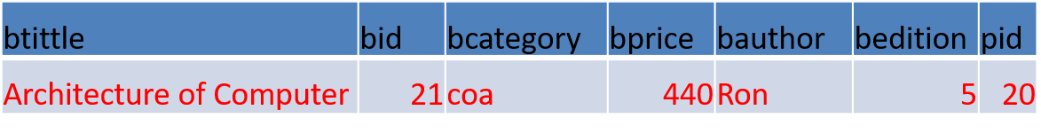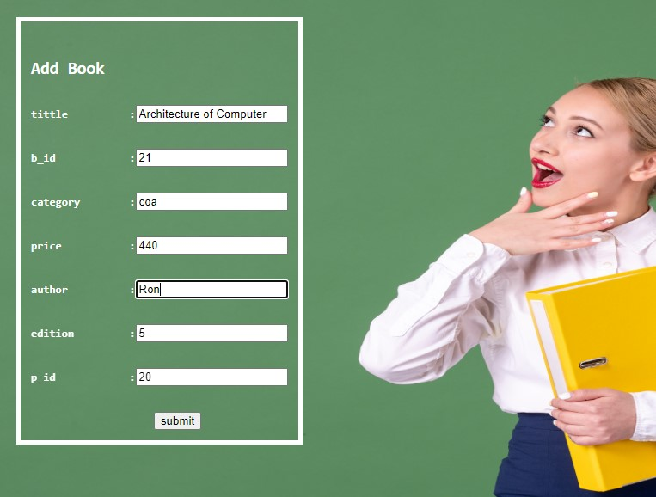

ADD PUBLISHER

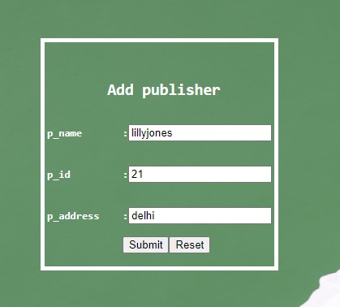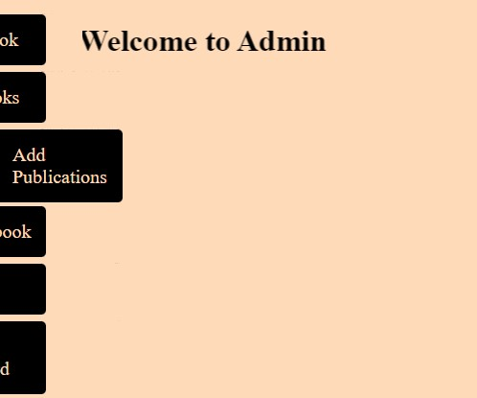

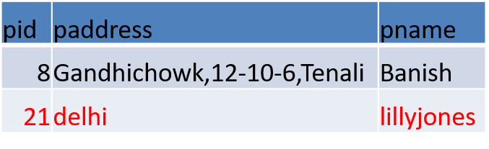

RETURN BOOK

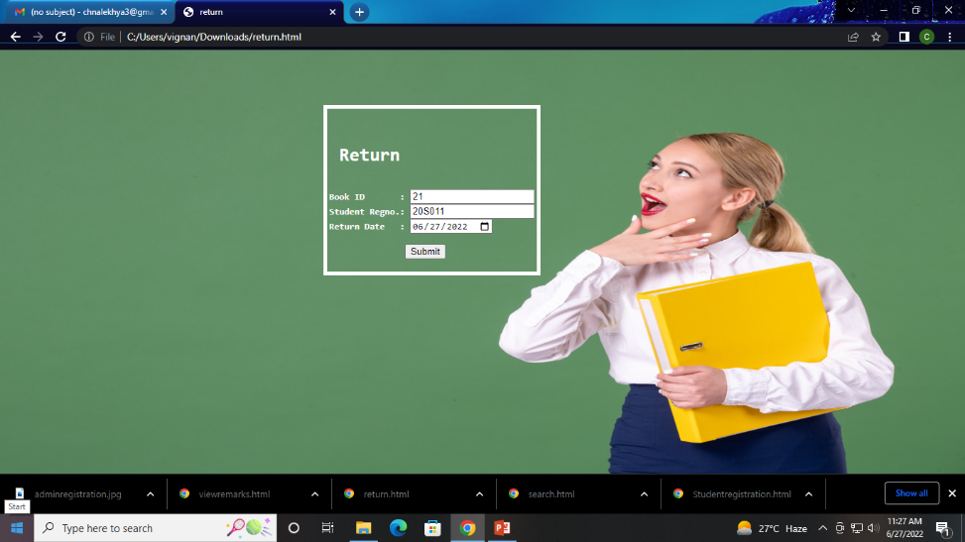

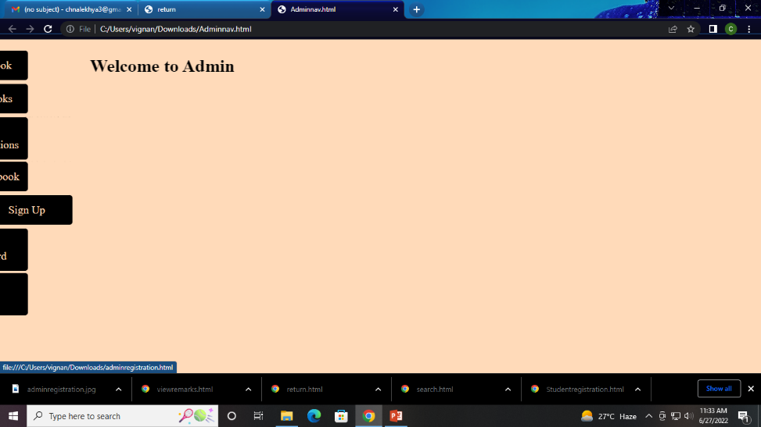ADMIN REGISTRATION

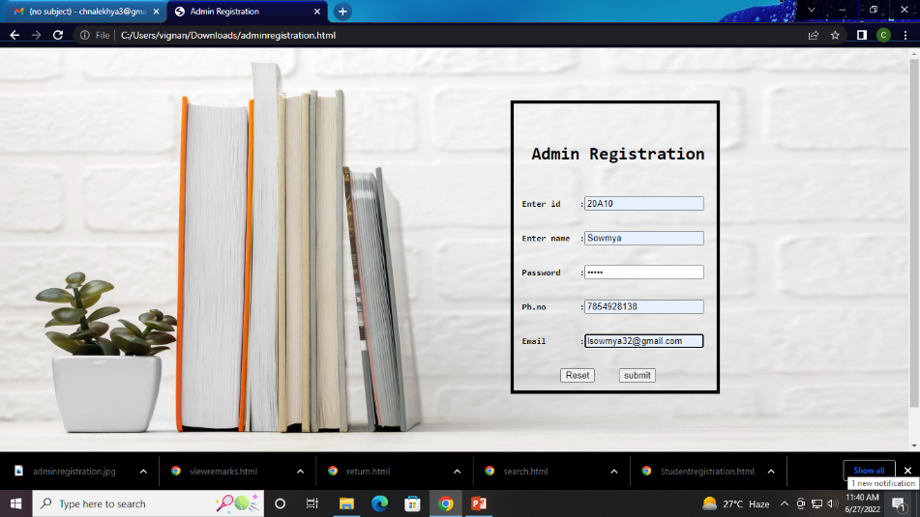

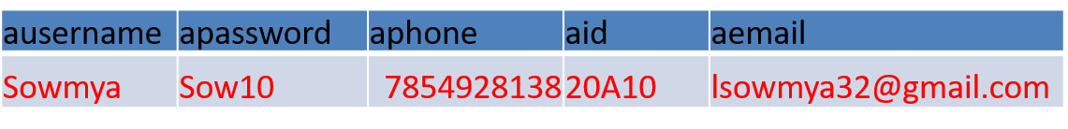

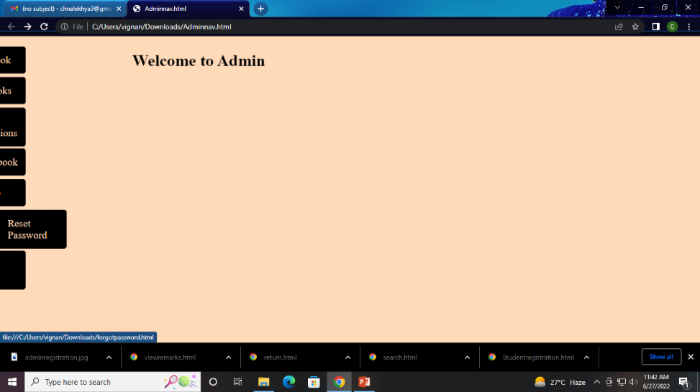RESET PASSWORD

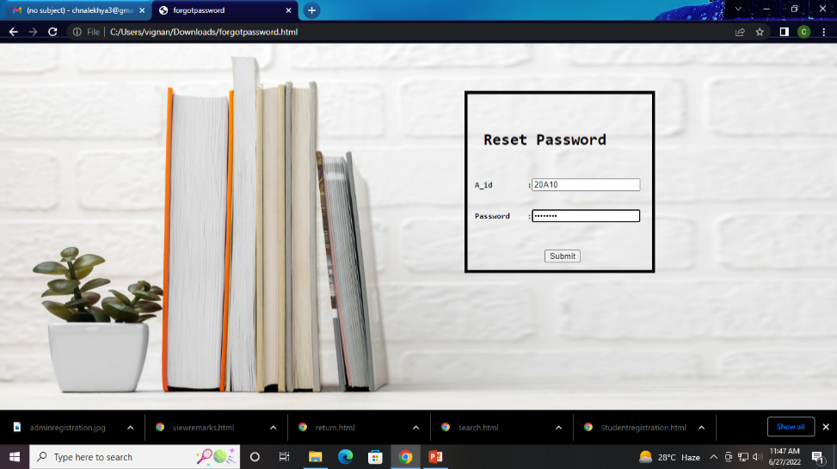

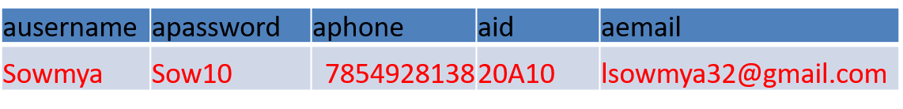

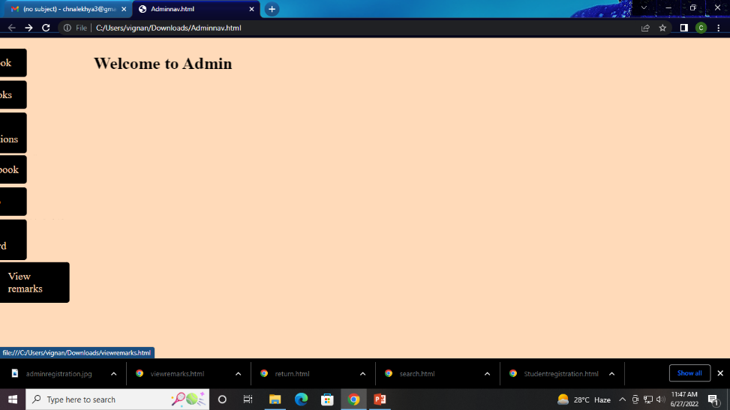VIEW REMARKS

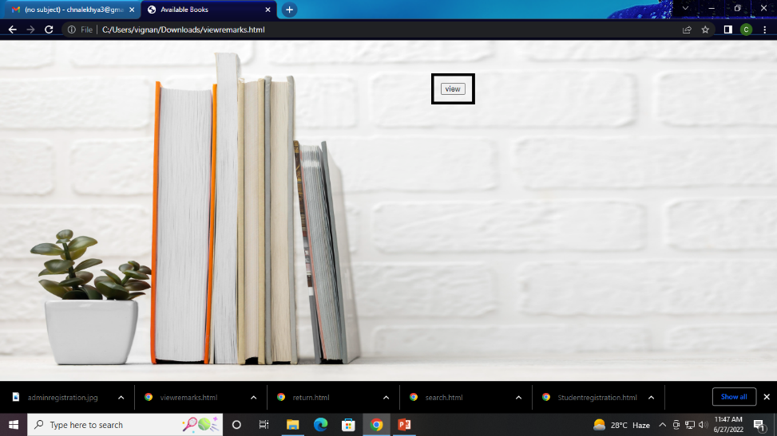

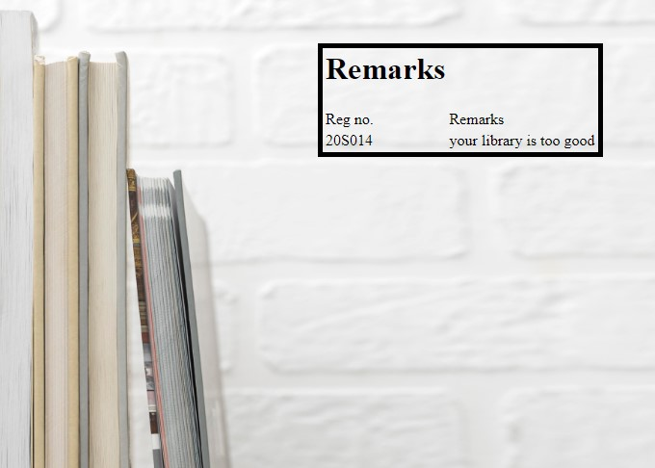

**6.REFERENCES**

[JavaScript Introduction (w3schools.com)](https://www.w3schools.com/js/js_intro.asp)

[SQL Tutorial (w3schools.com)](https://www.w3schools.com/sql/default.asp)

[CSS Tutorial (w3schools.com)](https://www.w3schools.com/css/default.asp)

[HTML Basic (w3schools.com)](https://www.w3schools.com/html/html_basic.asp)

[Learn Servlet Tutorial - javatpoint](https://www.javatpoint.com/servlet-tutorial)

[Establishing JDBC Connection in Java - GeeksforGeeks](https://www.geeksforgeeks.org/establishing-jdbc-connection-in-java/)

**7.CONCLUSION**

Library management system benefits the students as well as the staff of the library. Staff can search books , staff can generate reports and do book transactions. Implementation of this system will reduce data entry time and provide readily calculated reports.